**Case Study**

Fancy Accessory is a company that sells fashion accessories such as necklace, bracelet, earring and etc. The company has grown rapidly and so has the demand for the fashion accessories.

The company employs 6 people, and has office and warehouse space in an office park designed to encourage small businesses.

You and your development team have been asked to develop a new system for managing orders, billing and inventory for Fancy Accessory. The new Fancy Accessory Management System will help the company to improve the efficiency in handling their daily tasks.

1. Based on the case study given, design an **input form** and a **suitable report.**
2. Highlight the input/output design principles used.
3. Discuss main principals that the development teams should follow? Why these principals are important?

Auto generated

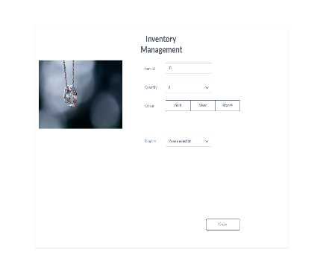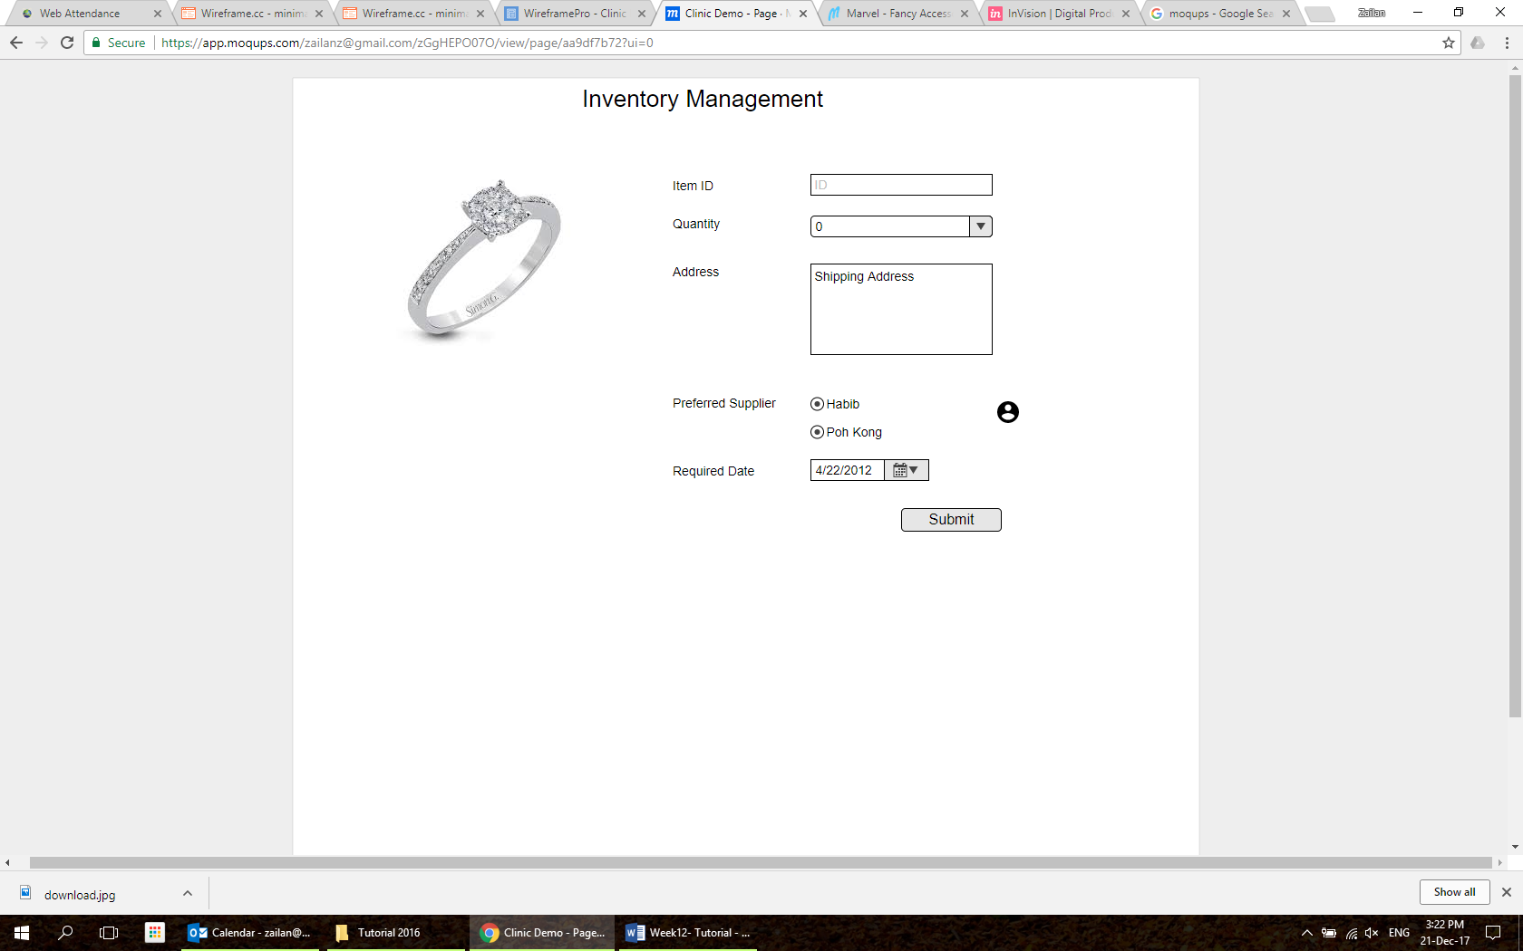

Auto generated

1. **Based on the case study given, design an input form and a suitable report.**

**Answer:**

Based on the case Fancy Accessory is a company that sells fashion accessories and they want to develop a system for management of order, and we are doing that devepment we need to insure the input from having following attributes:

For Order Entry Form:

* Customer Information:
  + Customer Name
  + Customer Address
  + Contact Information
* Order Details:
  + Item Code
  + Item Description
  + Quantity
  + Price per Unit
  + Total Cost
* Billing Information:
  + Payment Method
  + Discount (if any)
  + Total Amount
* Submit Button

And we prepare a order report form in following form

Order Summary Report:

* Customer Information:
  + Customer Name
  + Customer Address
  + Contact Information
* Order Details:
  + Order Date
  + Item Code
  + Item Description
  + Quantity
  + Price per Unit
  + Total Cost
* Billing Information:
  + Payment Method
  + Discount Applied
  + Total Amount
* Order Status (Processed, Pending, Shipped, Delivered)

**2. Highlight the input/output design principles used.**

**Answer**

My team need to develop the system according to Fancy Accessory SRS my team will use the following input/output principle:

Principles of Input/output Design:

* Ease of use: The form should be designed in a user-friendly manner, with clear lines and inputs organized logically.
* Consistency: Maintain consistency in formatting, wording, and structure across all inputs to reduce confusion and increase usability.
* Debugging and handling: Use input validation to debug, provide clear error messages, and make it easier for users to correct errors.

**Principles of Design:**

1. Clarity and Conciseness: Ensure that reports are clear, concise, and present information in an easy-to-understand manner.

2. Accuracy: The information presented in the report must be accurate and reflect the current status of orders, bills, and inventories.

3. Relevance: Include only relevant information in reports to avoid overwhelming users with unnecessary information.

**Development team principles that they need to focus upon according to SRS:**

1. User-Centered Design: Prioritize end-users’ needs and preferences to create systems that are efficient and user-friendly.

2. Modularity: Create a system with modular components, making it easier to maintain, update, and scale in the future.

3. Security: Implement security measures to protect sensitive customer business information.

4. Scalability: Design the system in a way that allows for future growth and increased system requirements.

5. Testing: Thoroughly test the system before using it to identify and correct any errors or problems.

Why are these principles important to Fancy Accessory?

The given design principle is important because of:

To increase Efficiency: Easy-to-use spreadsheets and clear reporting help make day-to-day operations more efficient.

To increase Accuracy: Accurate input and output is critical for reliable order processing and inventory management.

To increase User satisfaction: Following user-centered design principles results in higher user satisfaction and better acceptance. Satisfaction and better acceptance.

**2.Discuss main principals that the development teams should follow? Why these principals are important?**

**Answer:**

My team need to develop the system according to Fancy Accessory SRS my team will use the following main principals that my team will follow:

**User-Cantered Design:** Giving priority to user desires ensures that a gadget is intuitive and interesting, increasing consumer pride and adoption for Fancy Accessory.

**Modularity:** Modular additions simplify security, updates, and scalability, promoting adaptation to changing requirements and lowering development difficulties while we need to improve system of Fancy Accessory.

**Security:** Protecting sensitive records is critical for customer consideration and prison compliance, as well as lowering risks and ensuring a stable gadget environment for Fancy Accessory.

**Scalability:** Designing for scalability allows the device to grow easily, allowing increased demands and future enterprise development without major changes Fancy Accessory SRS.

**Testing:** Thorough testing finds and corrects faults, ensuring a strong, error-free system, increasing reliability, and lowering the possibility of post-deployment concerns Fancy Accessory SRS.

**Importance of principle we follow:**

* Efficiency is achieved by user-centered design, while modularity and scalability stimulate development and future optimization.
* User happiness: Implementation actions help to promote a positive user experience, as well as increased satisfaction and system acceptability.
* Security and dependability: Data protection fosters confidence, prevents breaches, adheres to legal and ethical norms, and protects the company's brand.
* Adaptability: The system's modularity and scalability allow it to adapt to changing needs, technology, and business advancements, assuring long-term survival.
* Dependability: Thorough testing enhances system dependability, decreases post-installation mistakes and deterioration, and boosts productivity.